**What is ASP.NET Web API?**

ASP.NET Web API is a framework that simplifies building HTTP services for broader range of clients (including browsers as well as mobile devices) on top of .NET Framework. Using ASP.NET Web API we can create non-SOAP based services like plain XML or JSON strings etc. with many other advantages including:

* Create resource-oriented services using the full features of HTTP.
* Exposing services to a variety of clients easily like browsers or mobile devices etc.

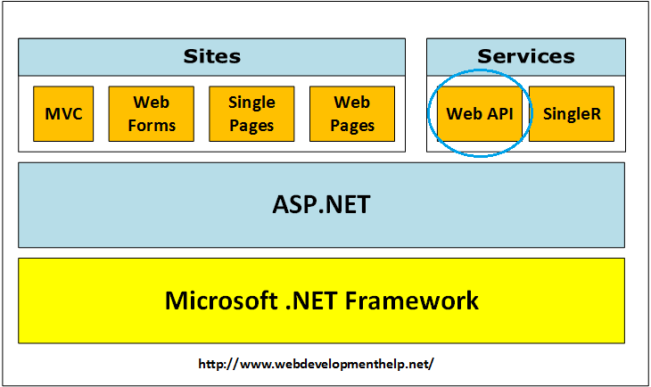[Back to top](http://www.webdevelopmenthelp.net/2014/05/asp-net-web-api-interview-questions.html#top)

**What are the advantages of using ASP.NET Web API?**

Using ASP.NET Web API has a number of advantages, but core of the advantages are:

* It works the HTTP way using standard HTTP verbs like GET, POST, PUT, DELETE etc for all CRUD operations.
* Complete support for routing.
* Response generated in JSON or XML format using MediaTypeFormatter.
* It has the ability to be hosted in IIS as well as self-host outside of IIS.
* Supports Model binding and Validation.
* Support for OData.
* and more….

For implementation on performing all CRUD operations using ASP.NET Web API, [click here](http://www.webdevelopmenthelp.net/2013/12/performing-crud-operations-using-asp-net-web-api-part-1.html).[](http://www.webdevelopmenthelp.net/exams-70-486)

[Back to top](http://www.webdevelopmenthelp.net/2014/05/asp-net-web-api-interview-questions.html#top)

**What new features are introduced in ASP.NET Web API 2.0?**

More new features introduced in ASP.NET Web API framework v2.0 are as follows:

* Attribute Routing
* External Authentication
* CORS (Cross-Origin Resource Sharing)
* OWIN (Open Web Interface for .NET) Self Hosting
* IHttpActionResult
* Web API OData

You can follow a good Web API new feature details on [Top 5 New Features in ASP.NET Web API 2](http://www.webdevelopmenthelp.net/2013/10/top-5-new-features-in-asp-net-web-api-2.html) here.

[Back to top](http://www.webdevelopmenthelp.net/2014/05/asp-net-web-api-interview-questions.html#top)

**WCF Vs ASP.NET Web API?**

Actually, **Windows Communication Foundation** is designed to exchange standard SOAP-based messages using variety of transport protocols like HTTP, TCP, NamedPipes or MSMQ etc. On the other hand, **ASP.NET API** is a framework for building non-SOAP based services over HTTP only.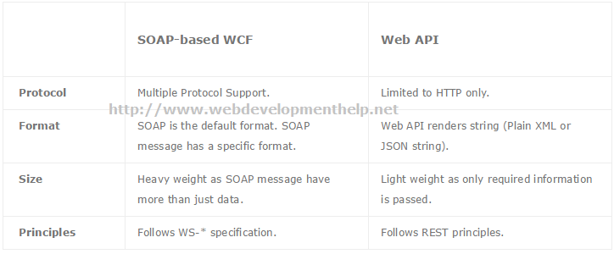[Back to top](http://www.webdevelopmenthelp.net/2014/05/asp-net-web-api-interview-questions.html#top)

**WCF RESTful Service Vs ASP.NET Web API?**

Although both WCF REST and ASP.NET Web API follows the REST architecture but these have follow differences:

**WCF REST**

* Microsoft introduced “WebHttpBinding” to be used for creating WCF RESTful Services.
* HTTP Methods are mapped to attributes, for example, “WebGet” for GET method and “WebInvoke” for POST.

**ASP.NET Web API**

* As compared with WCF REST, Web API supports full features of HTTP.
* Its possible to host Web API in IIS as well as in an application.

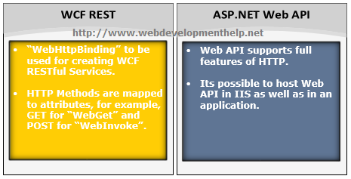[Back to top](http://www.webdevelopmenthelp.net/2014/05/asp-net-web-api-interview-questions.html#top)

**Is it true that ASP.NET Web API has replaced WCF?**

It’s a misconception that ASP.NET Web API has replaced WCF. It’s another way of building non-SOAP based services, for example, plain XML or JSON string etc.

Yes, it has some added advantages like utilizing full features of HTTP and reaching more clients such as mobile devices etc.

But WCF is still a good choice for following scenarios:

* If we intended to use transport other than HTTP e.g. TCP, UDP or Named Pipes.
* Messag Queuing scenario using MSMQ.
* One-way communication or Duplex communication

A good understanding for WCF(Windows Communication Foundation), please follow [WCF Tutorial](http://www.topwcftutorials.net/).

[Back to top](http://www.webdevelopmenthelp.net/2014/05/asp-net-web-api-interview-questions.html#top)

**MVC Vs ASP.NET Web API?**

As in previous ASP.NET Web API Interview Questions, we discussed that purpose of Web API framework is to generate HTTP services that reaches more clients by generating data in raw format, for example, plain XML or JSON string. So, ASP.NET Web API creates simple HTTP services that renders raw data. On the other hand, ASP.NET MVC framework is used to develop web applications that generates Views as well as data. ASP.NET MVC facilitates in rendering HTML easy.

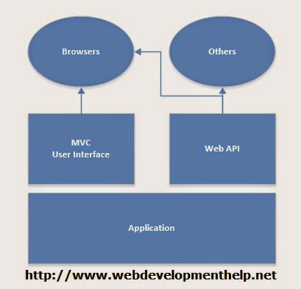

For **ASP.NET MVC Interview Questions**, [follow the link](http://www.webdevelopmenthelp.net/2013/09/top-10-asp-net-mvc-interview-questions.html).  
[Back to top](http://www.webdevelopmenthelp.net/2014/05/asp-net-web-api-interview-questions.html#top)

[**Answer this simple Question to test your skill?**](http://www.webdevelopmenthelp.net/2014/05/asp-net-web-api-interview-questions.html#acc-3)

Please look into following piece of code:

[ActionName(“GetById”)]

public ActionResult GetEmployeeById()  
{  
//Code logic here.

return View();  
}  
What’s true about the above code.

* A. “GetEmployeeById” action method with be identified and called by name “GetEmployeeById”.
* B. “GetEmployeeById” action method with be identified and called by name “GetById”.
* C. Above code will generate an error because of wrong return type.
* D. Action method can’t be called because of duplicate action method names.

*For a complete online test and Practice Exams on Web Technologies,*[*Click Here*](http://www.webdevelopmenthelp.net/free-online-test)*.*

**Correct Answer: B**

**How to return View from ASP.NET Web API method?**

(A tricky Interview Question) No, we can’t return view from ASP.NET Web API Method. As we discussed in earlier interview question about difference between ASP.NET MVC and Web API that ASP.NET Web API creates HTTP services that renders raw data. Although, it’s quite possible in ASP.NET MVC application.  
[Back to top](http://www.webdevelopmenthelp.net/2014/05/asp-net-web-api-interview-questions.html#top)

**How to restrict access to Web API method to specific HTTP Verb?**

**Attribute programming** plays it’s role here. We can easily restrict access to an ASP.NET Web API method to be called using a specific HTTP method. For example, we may required in a scenario to restrict access to a Web API method through HTTP POST only as follows:

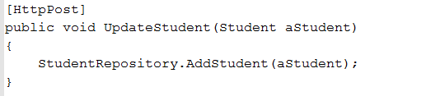

[Back to top](http://www.webdevelopmenthelp.net/2014/05/asp-net-web-api-interview-questions.html#top)

**Can we use Web API with ASP.NET Web Form?**

Yes, ASP.NET Web API is bundled with ASP.NET MVC framework but still it can be used with ASP.NET Web Form. It can be done in three simple steps as follows:

1. Create a Web API Controller.
2. Add a routing table to Application_Start method of Global.asax.
3. Make a jQuery AJAX Call to Web API method and get data.

[jQuery call to Web API](http://www.webdevelopmenthelp.net/2014/01/performing-crud-operations-using-asp-net-web-api-part-2.html) for all CRUD (Create, Retrieve, Update, Delete) operations can be [found here](http://www.webdevelopmenthelp.net/2014/01/performing-crud-operations-using-asp-net-web-api-part-2.html).

[Back to top](http://www.webdevelopmenthelp.net/2014/05/asp-net-web-api-interview-questions.html#top)

**How we can provide an alias name for ASP.NET Web API action?**

We can provide an alias name for ASP.NET Web API action same as in case of ASP.NET MVC by using “ActionName” attribute as follows:

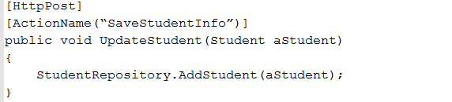  
[Back to top](http://www.webdevelopmenthelp.net/2014/05/asp-net-web-api-interview-questions.html#top)

[Back to top](http://www.webdevelopmenthelp.net/2014/05/asp-net-web-api-interview-questions.html#top)

**What are Exception Filters? What are different ways to register exception filters?**

Exception Filter is basically a class that implements IExceptionFilter interface. While working with ASP.NET Web API, there can be scenarios where the code can generate unhandled exceptions. And for those unhandled exceptions, client will be receiving same generic error i.e. “Internal Server Error”. In order to tackle such unhandled exceptions, Exception Filters can be used.

You can follow here for a detailed article on [Exception Handling in ASP.NET Web API](http://www.webdevelopmenthelp.net/2014/02/exception-handling-asp-web-api.html) with following implementation:

* What are Exception Filters in Web API?
* How we can create a Custom Exception Filter?
* How we can register Custom Exception Filter at different levels?

We can register exception filters for ASP.NET Web API in following different levels:

* *Register Exception Filter from action*  
  [MyCustomExceptionFilter] public Student Get(string id)  
  {  
  return StudentRepository.GetStudent(id);  
  }
* Register Exception Filter from Controller  
  [MyCustomExceptionFilter] public class StudentsController : ApiController  
  {  
  //Controller detailed code.  
  }
* Register Exception Filter globally  
  CRUDWebAPI.MyCustomExceptionFilter ctrlr = new CRUDWebAPI.MyCustomExceptionFilter(); GlobalConfiguration.Configuration.Filters(ctrlr);

|  |
| --- |
| **What is ASP.NET Web API?** |
| Web API is an open source framework to build HTTP services for broader range of clients including browsers, tablets as well as mobile phones following REST principles. It contains many of the features of MVC e.g. controllers, filters, routing etc. It can be used to develop web services applications. We can host it within the application or on IIS. |
|  |
| **2. What are the advantages of using ASP.NET Web API?** |
| It is an open source technology. It uses HTTP hence easy to use and handle it. It can be hosted in IIS as well as self-host outside of IIS. It supports OData. It also has full support for routing. For developing service for low bandwidth device like mobile phones, it is very good alternative due to its being light weight. If we need non-SOAP based HTTP service then it is the best option. |
|  |
| **3. Differentiate between WCF and Web API.** |
| **WCF** - Windows Communication Foundation(WCF) has been created by Microsoft with .NET Framework 3.0. It supports SOAP based services. It has compatibility with HTTP, TCP, UDP, etc. Good for developing secure and interoperable services. Used for back end purposes. **WEB API** - Web API open source framework. It has compatibility with HTTP only. It has a support for non-SOAP based services. It is very light weight hence good for developing services for low bandwidth devices. It supports OData. It supports most of the MVC features. Used for front end purposes. |
|  |
| **4. What is SOAP?** |
| Simple Object Access Protocol (SOAP) is a protocol created by Microsoft in 1998. Structured format data can be created using SOAP that can travel over the internet. WCF uses SOAP based services. SOAP can operate over any transfer protocol like HTTP, SMTP, TCP etc. SOAP has 3 basic characteristics i.e. extensibility, neutrality and independence. A SOAP message is an ordinary XML document containing 4 elements Envelope, Header, Body and Fault. |
|  |
| **5. What is REST?** |
| Representational State Transfer (REST) is an architectural style which is consisting of a coordinated set of components and defined guidelines for creating services which are scalable. It is used with HTTP protocol using its verbs GET, POST, PUT and DELETE. REST does not require much bandwidth hence it is a better alternative for use over the Internet. Whenever web services use REST architecture, they are termed as RESTful APIs. REST is mainly used in developing mobile applications, social networking websites, cloud-based platforms etc. |
|  |
| **6. Differentiate between MVC and Web API.** |
| **MVC** - MVC is used to develop web applications. MVC returns the data only in JSON format using JsonResult from action method. All requests are mapped to the respective action methods. In MVC, controllers, filters, routing etc. features exist in System.Web.Mvc. It is used to develop web applications which return both view and data. **WEB API** - Web API open source framework. It has compatibility with HTTP only. It has a support for non-SOAP based services. It is very light weight hence good for developing services for low bandwidth devices. All requests are mapped to the actions based on HTTP verbs. It supports most of the MVC features like controllers, filters, routing etc. features exist in System.Web.Http. Web API returns the data in particular format like JSON,XML or any other based upon the Accept header. |
|  |
| **7. How can we use Web API with ASP.NET Web Form?** |
| Web can be used with ASP.NET Web Form. It can be done in three simple steps: 1. You need to create a Web API Controller, 2. You have to add a routing table to Application_Start method of Global.asax and 3. You are required to make a jQuery AJAX Call to Web API method and get data. |
|  |
| **8. Which top 5 New Features have been included in ASP.NET Web API 2?** |
| 1.Attribute Routing, 2. CORS � Cross Origin Resource Sharing, 3. OWIN (Open Web Interface for .NET) self hosting, 4. IHttpActionResult and 5. Web API OData |
|  |
| **9. What is TestApi?** |
| TestApi is a library of utility and test APIs through which testers and developers create testing tools and automated tests for .NET and Win32 application using data-structure and algorithms. |
|  |
| **10. What are Exception Filters?** |
| Exception filters will be executed when some of the exceptions are unhandled and thrown from a controller method. The reason for the exception may be anything. Exception filters will implement "IExceptionFilter" interface. |
|  |